Connecting to OSA-BYOD – Windows Vista
James Preston
30/04/2014

Overview
This guide shows how to connect to the free OSA-BYOD wireless network on a PC powered by Windows Vista.

Further assistance
If after following this guide further assistance is required contact ICT Services on ictservicedesk@oxfordspiresacademy.org.

Prerequisites
You must have a valid Oxford Spires Academy user account to be able to complete these steps.

Guide
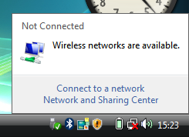 | On the bottom right hand corner of your desktop click the networking icon then click on Network and Sharing Centre.
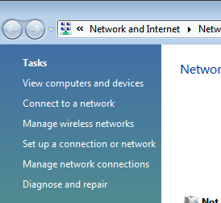 | On the left hand side of the window that appears click on Manage wireless networks.
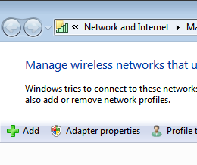 | Click Add.
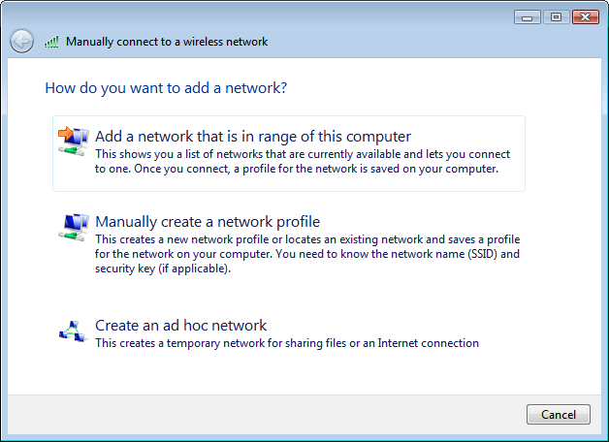 | Click Manually create a network profile.
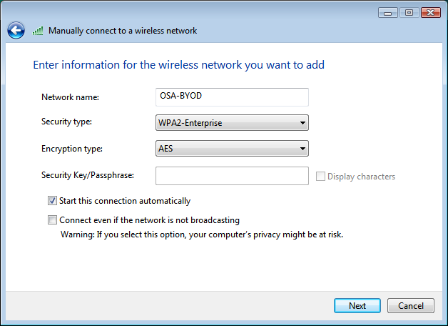 | In Network name type OSA-BYOD.  Under Security type select WPA2-Enterprise.  Click next.
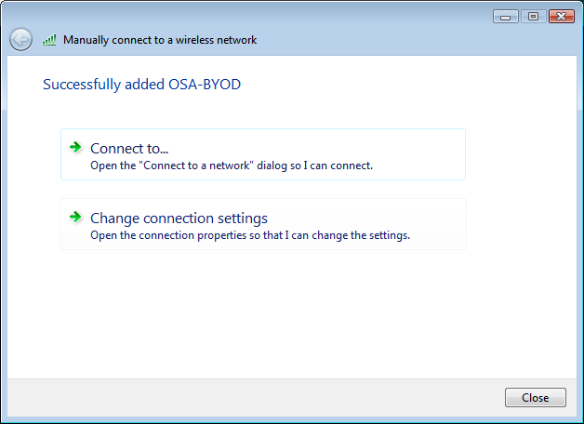 | Click Change connection settings.
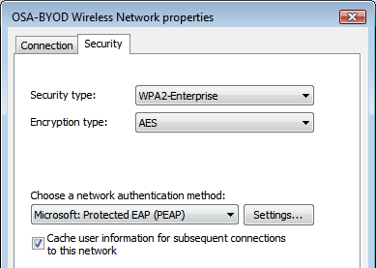 | In the window that appears click on the Security tab and then click on Settings.
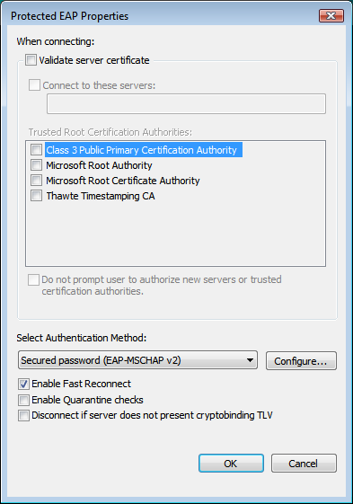 | Un tick Validate server certificate and then click Configure.
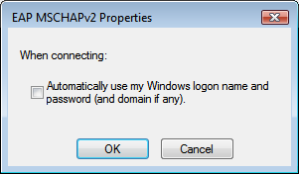 | Un tick Automatically use my Windows logon name and password.  Click OK to close the window, then click ok/close on any remaining windows.
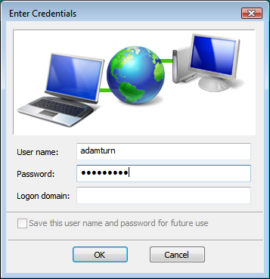 | You will then be prompted to enter a username and password to connect to the network. Enter the same username and password that you use to login to Academy computers and then click OK.
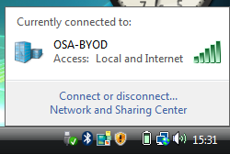 | You will now be connected to the OSA-BYOD network.

