Connecting to OSA-BYOD – Windows Phone
James Preston
28/04/2014

Overview
This guide shows how to connect to the free OSA-BYOD wireless network on a Windows Phone.

Further assistance
If after following this guide further assistance is required contact ICT Services on ictservicedesk@oxfordspiresacademy.org.

Prerequisites
You must have a valid Oxford Spires Academy user account to be able to complete these steps.

Guide
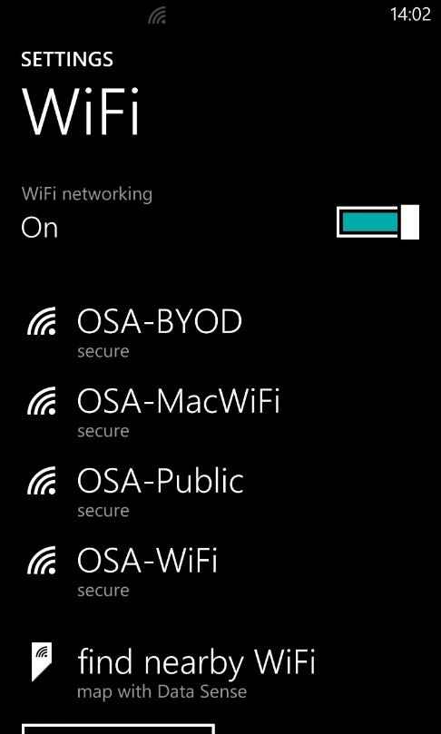 | Navigate to WiFi in settings, turn on WiFi and then tap on OSA-BYOD to connect.
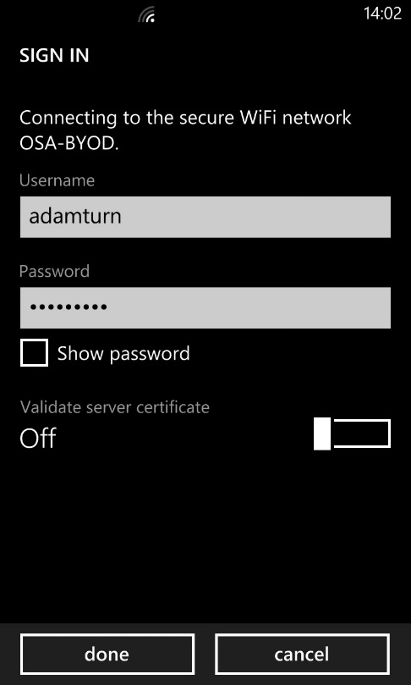 | When prompted enter the same username and password that you use to login to Academy computers and then tap done.
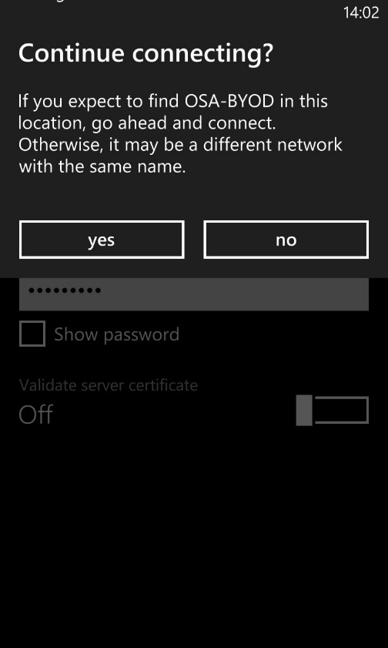 | When prompted if you wish to continue connecting tap yes.
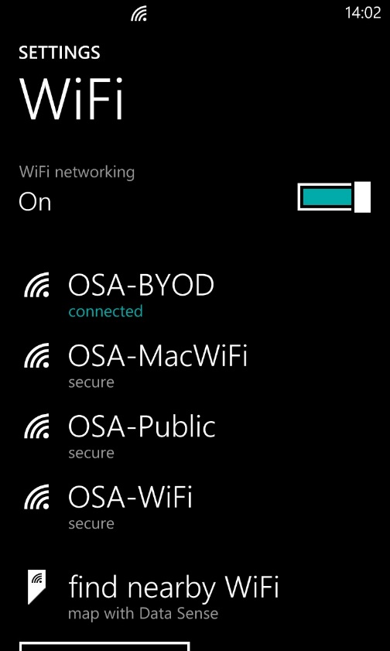 | You will now be connected to the OSA-BYOD network which gives you free internet access at your permissions level.  If you change your account password you will be prompted to change the password to connect to the wireless as well.

