Connecting to OSA-BYOD – Windows 8
James Preston
30/04/2014

Overview
This guide shows how to connect to the free OSA-BYOD wireless network on a PC powered by Windows 8.

Further assistance
If after following this guide further assistance is required contact ICT Services on ictservicedesk@oxfordspiresacademy.org.

Prerequisites
You must have a valid Oxford Spires Academy user account to be able to complete these steps.

Guide
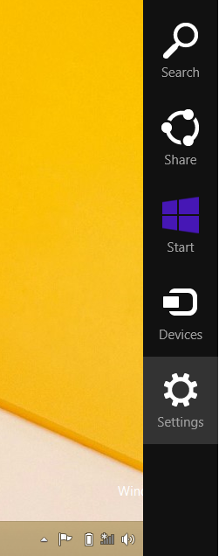 | Swipe in from the right to display the charms bar and then click/tap Settings.
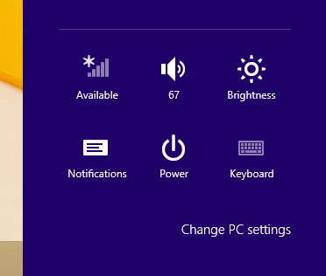 | Click/tap the wireless network icon.
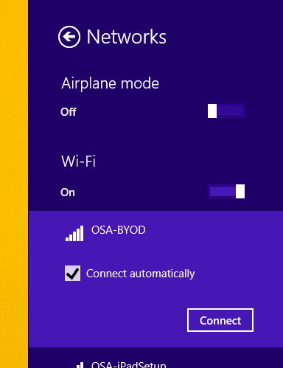 | Click/tap the OSA-BYOD network and then click/tap Connect.
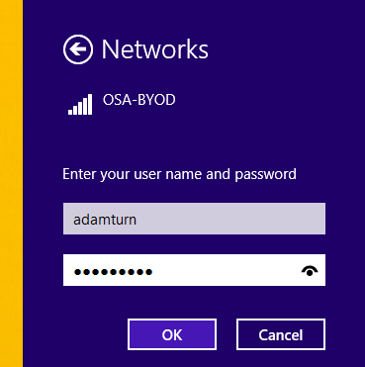 | Enter the same username and password that you use to login to Academy computers.  Click/tap OK.
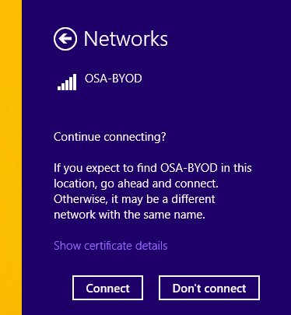 | If prompted click/tap Connect.
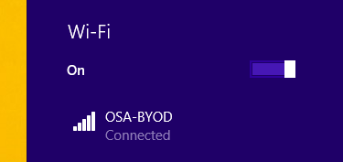 | You will now be connected to the OSA-BYOD network.

