Connecting to OSA-BYOD – Windows 7
James Preston
30/04/2014

Overview
This guide shows how to connect to the free OSA-BYOD wireless network on a PC powered by Windows 7.

Further assistance
If after following this guide further assistance is required contact ICT Services on ictservicedesk@oxfordspiresacademy.org.

Prerequisites
You must have a valid Oxford Spires Academy user account to be able to complete these steps.

Guide
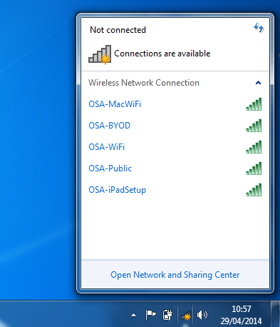 | Click the networking icon and then click Open Networking and Sharing Centre.
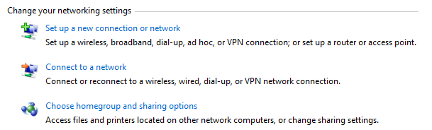 | In the centre area of the window that appears click Set up a new connection or network.
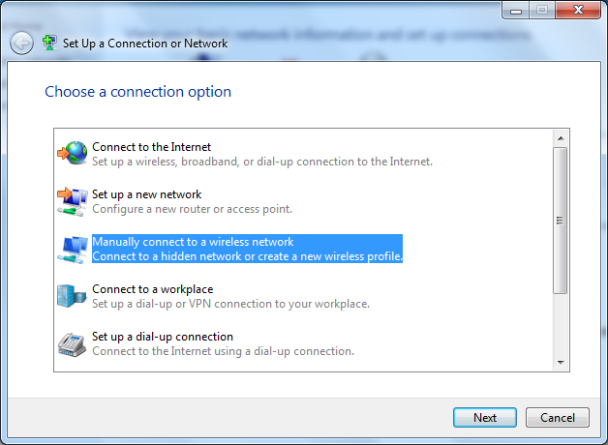 | Click Manually connect to a wireless network.
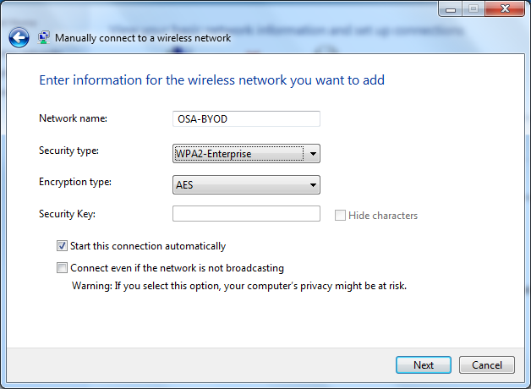 | In Network name type OSA-BYOD.  Under Security type select WPA2-Enterprise.  Click Next.
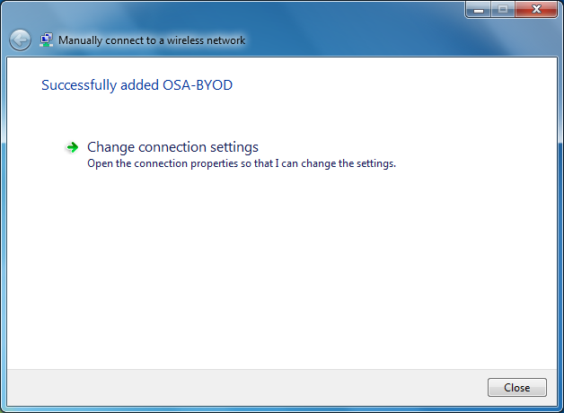 | Click Change connection settings.
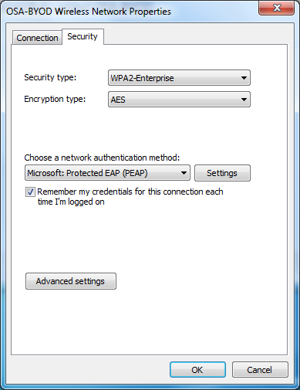 | Select the Security tab and click Settings.
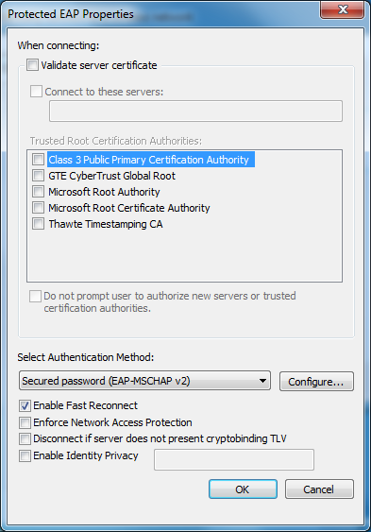 | Un tick Validate server certificate and then click Configure.
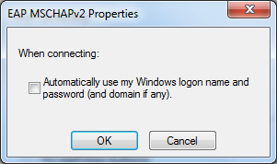 | Un tick Automatically use my Windows logon name and password.  Click OK to close the window, then click ok on the ‘Protected EAP Properties’ Window.
 | Return to the Security tab and click Advanced settings.
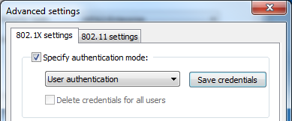 | Tick Specify authentication mode, select User authentication from the drop down box and then click Save credentials.
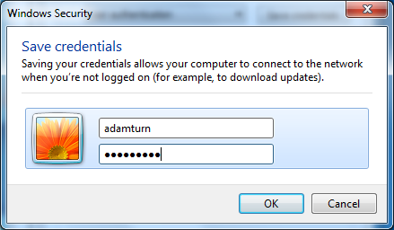 | Enter the same username and password that you use to login to computers and then click OK.  Click OK to close the window, then click ok/close on any remaining windows.
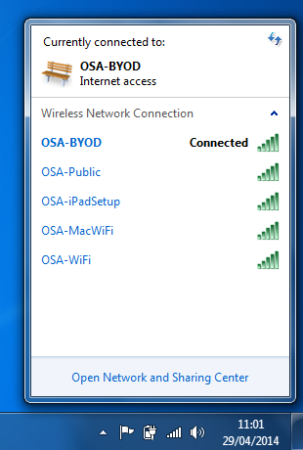 | You will now be connected to the OSA-BYOD network.

