Connecting to OSA-BYOD – iOS
James Preston
06/06/2014

Overview
This guide shows how to connect to the free OSA-BYOD wireless network on devices powered by iOS (e.g. the iPhone/iPad/iPod Touch). This example shows an iPad running iOS version 7.1.1.

Further assistance
If after following this guide further assistance is required contact ICT Services on ictservicedesk@oxfordspiresacademy.org.

Prerequisites
You must have a valid Oxford Spires Academy user account to be able to complete these steps.

Guide
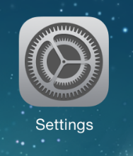 | Browse to Settings.
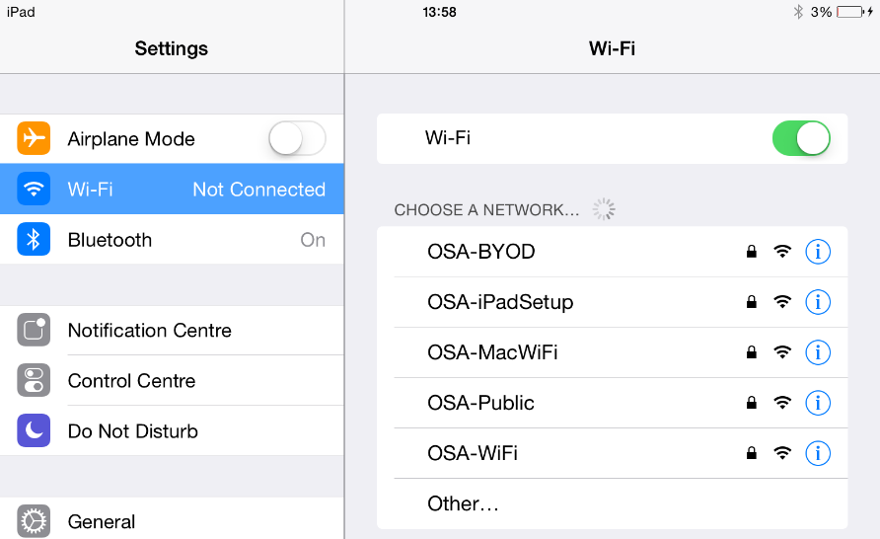 | Browse to Wi-Fi, if not already turned on turn on Wi-Fi and then tap on the OSA-BYOD network.
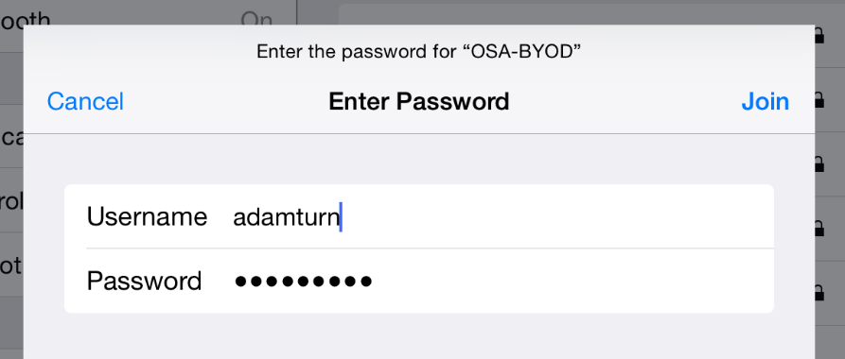 | When prompted enter the same username and password that you use to login to Academy computers. Then tap Join.
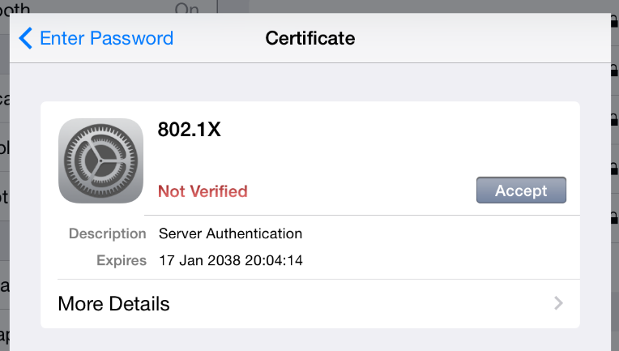 | If prompted to accept a security certificate tap the Accept button.  You will now be connected to the OSA-BYOD network.

