Connecting to OSA-BYOD – Android
James Preston & Sam Adams
07/05/2014

Overview
This guide shows how to connect to the free OSA-BYOD wireless network on a Google Android phone. The phone used in the following example is an HTC One X running Android 4.0. It may very slightly on different versions but will be largely the same.

Further assistance
If after following this guide further assistance is required contact ICT Services on ictservicedesk@oxfordspiresacademy.org.

Prerequisites
You must have a valid Oxford Spires Academy user account to be able to complete these steps.

Guide
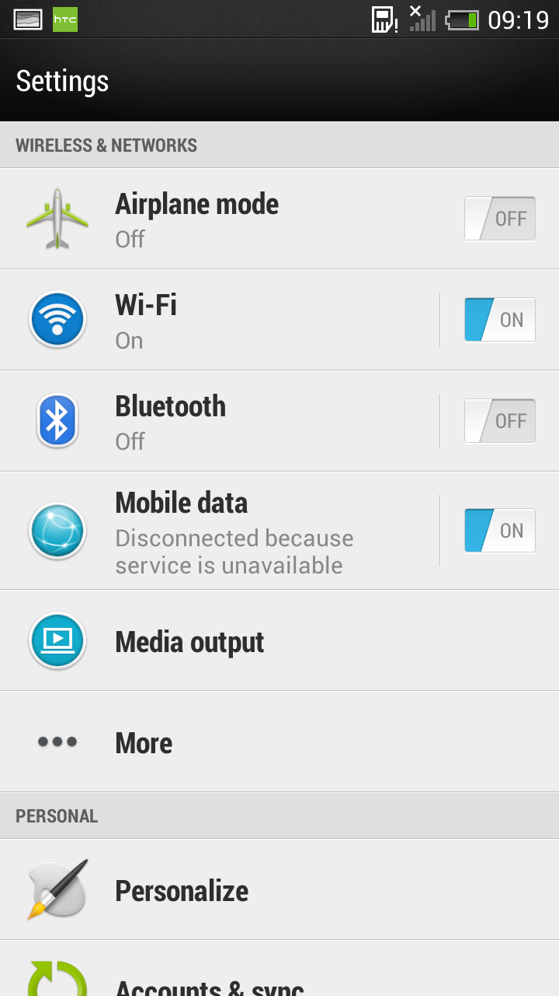 | Navigate to the “WiFi” settings from the Settings application.
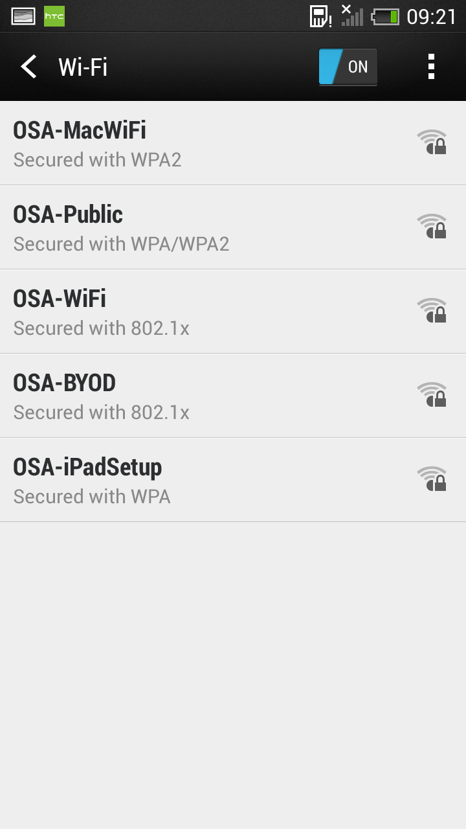 | Ensure Wifi is turned on and select the OSA-BYOD network by tapping on it.
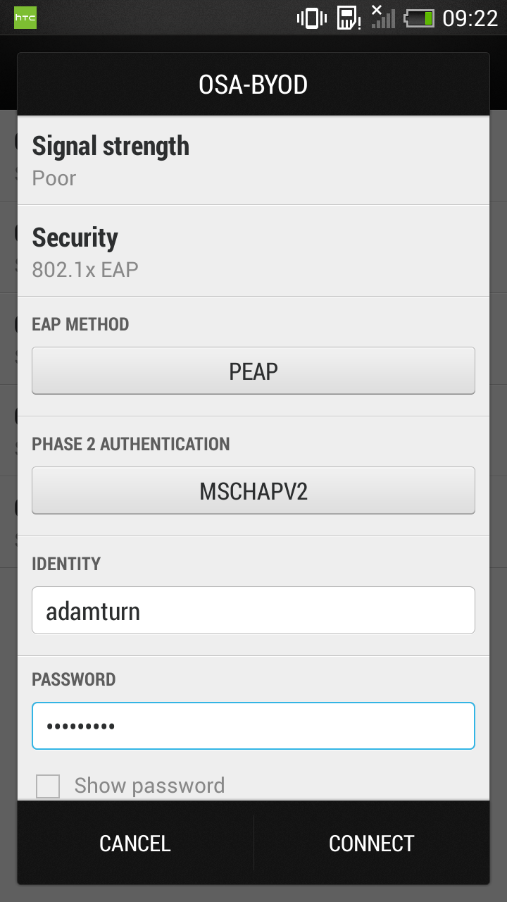 | In the “Identity” box enter your school username. In the password box enter your school password. Ensure that the EAP method is set to PEAP and the Phase 2 Authentication is set to MSCHAPV2 (which it is likely by default). Press connect.
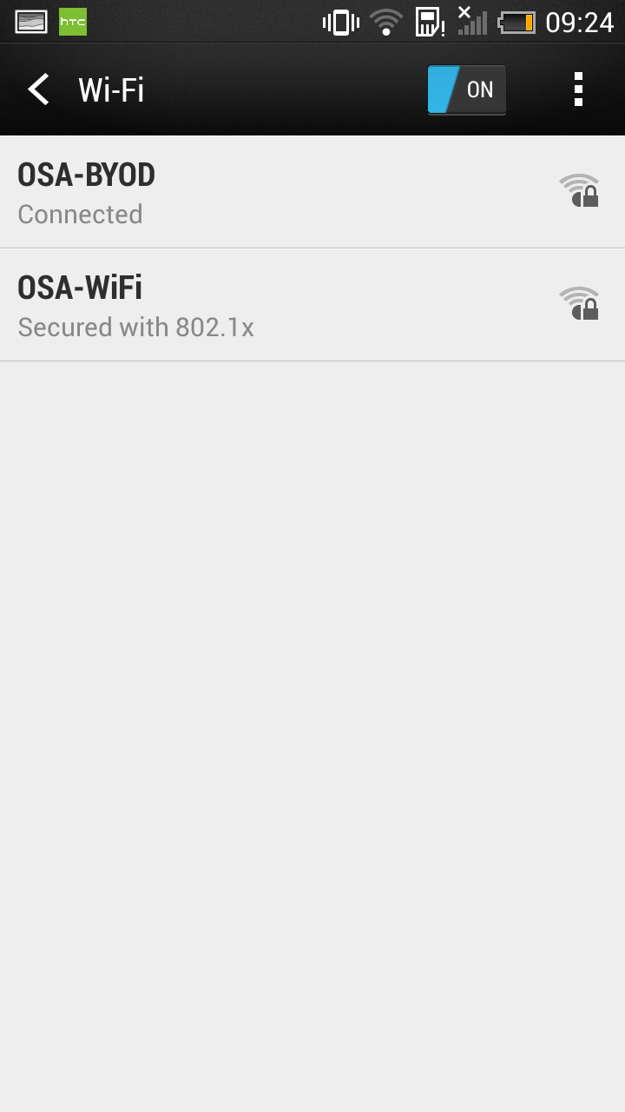 | You will now be connected to the OSA-BYOD network which gives you free internet access at your permissions level.  If you change your account password you will be prompted to change the password to connect to the wireless as well.

