Using Cloud
<yournamehere>
08/01/2014

Overview
This guide shows how to download, edit and the upload a document (be it Word/Excel/PowerPoint) from/to Cloud.

Further assistance
If after following this guide further assistance is required contact ICT Services on <yourictservicesemailhere>.

Prerequisites
You must have an active internet connection, the iWork suite installed (Pages, Numbers and Keynote) and WebDAV Navigator setup (separate guide available for this).

Guide

Importing the document into iWork
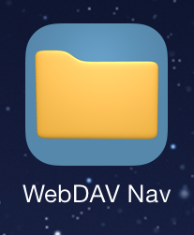 | Launch the WebDAV Nav app.
<putpictureinhere> | Browse to a document that you want to edit, tap and hold on it until…
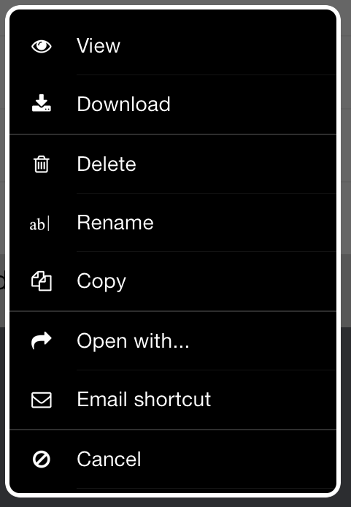 | ..this window appears.  Then tap on the Open with… icon.
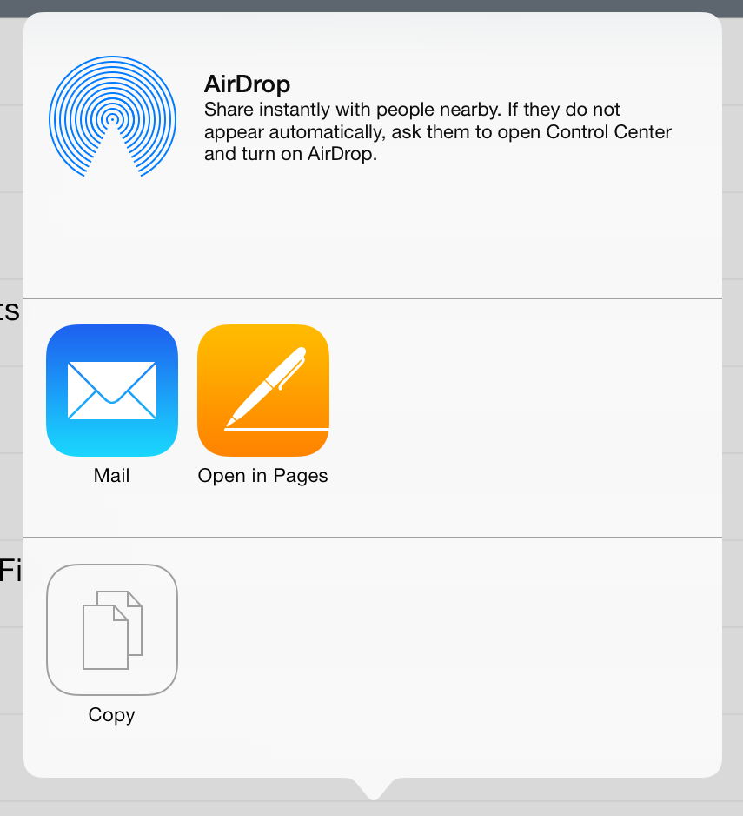 | In this case the document is a Word document so tap on Open in Pages.
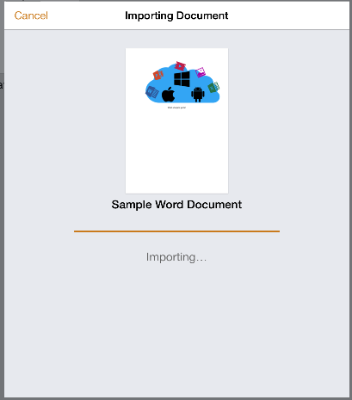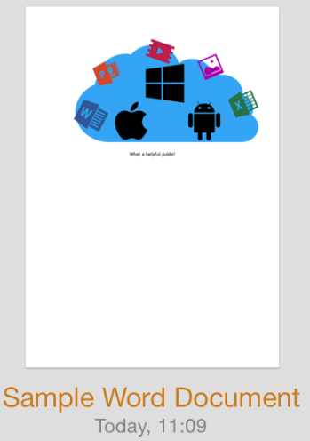 | The document will then be imported into pages and you will be able to edit it even if you don’t have an internet connection.

Uploading the document to OSA Cloud
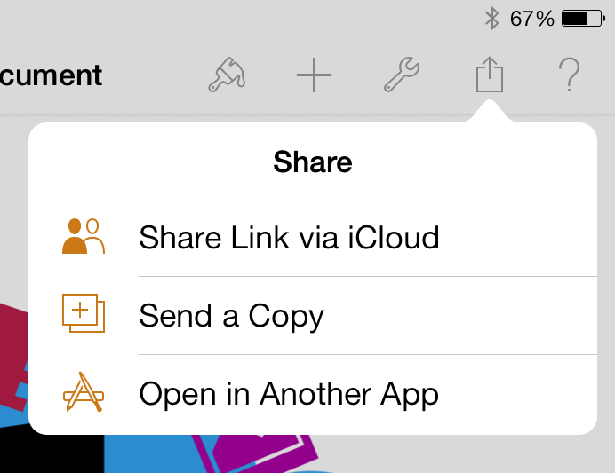 | Once you have finished editing the document you must upload it back to the Cloud.  In the top right hand corner of the screen tap the upload icon and tap on Open in Another App.
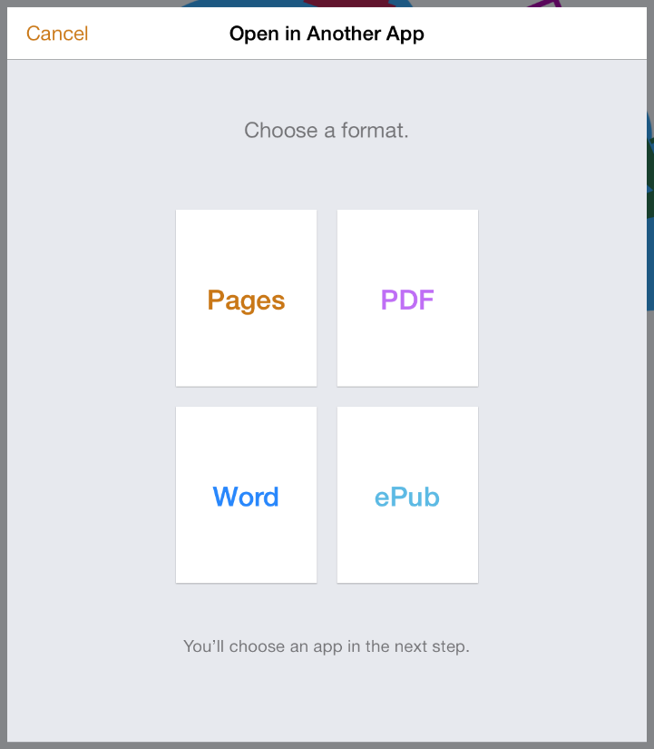 | In this example the document is a Word document (and so tap on Word).  If it were a PowerPoint or Excel document tap on PowerPoint or Excel.
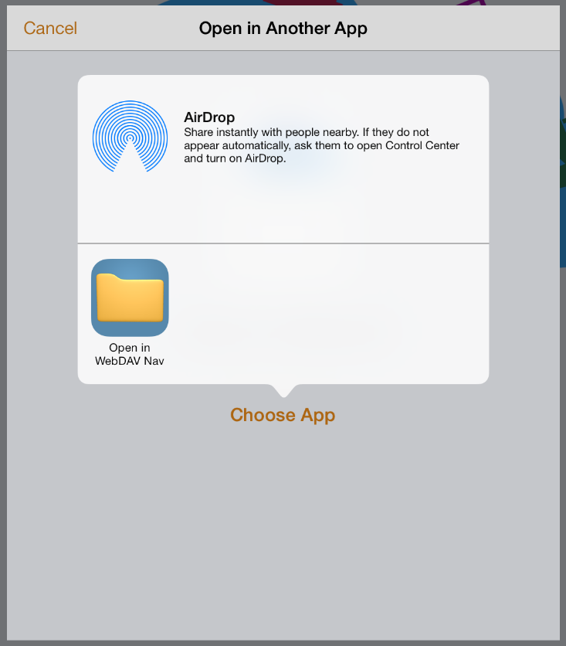 | Next tap on Choose App and then tap on Open in WebDAV Nav.
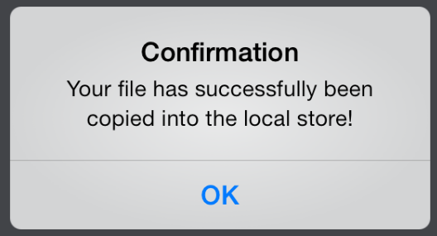 | WebDAV Nav will then open, tap OK.  Note – the document has NOT been uploaded yet.
<putpictureinhere> | Browse to where you want to upload the document (this could be the same place where you downloaded the document from).  Tap the upload/download icon in the bottom right hand corner.
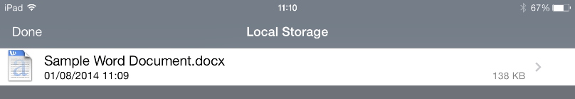 | A list will appear which will include the document you want to upload.  Tap and hold on it…
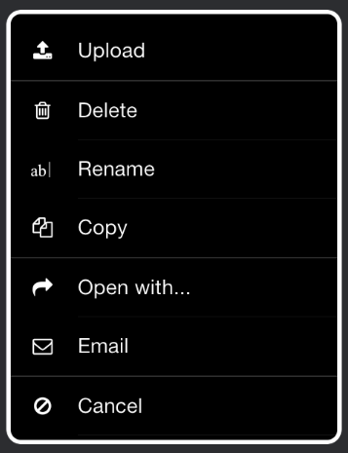 | Tap Upload.
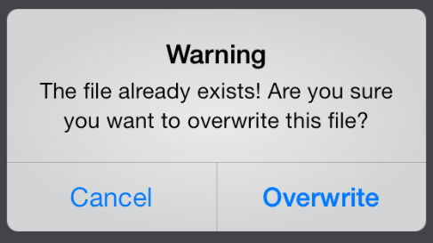 | If you are uploading the document into the same place where you originally downloaded it from you will get this warning messages, just tap Overwrite.
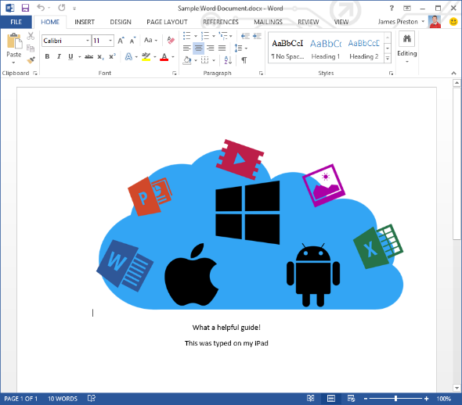 | You will then be able to open/edit the document on any normal Windows PC.

