Using Cloud
<yournamehere>
02/01/2014

Overview
This guide shows how to connect to Cloud on a Windows 8 PC.

Further assistance
If after following this guide further assistance is required contact ICT Services on <yourictservicesemailhere>.

Prerequisites
You must have an active internet connection and a valid user account to be able to complete these steps.

Guide
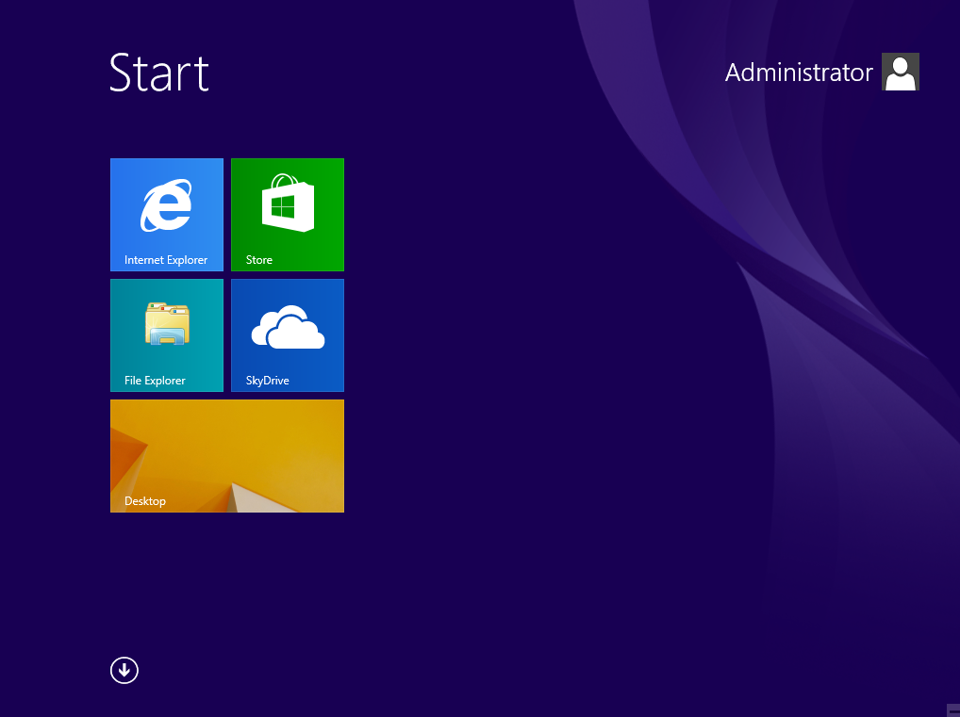 | From the Start screen click File Explorer.
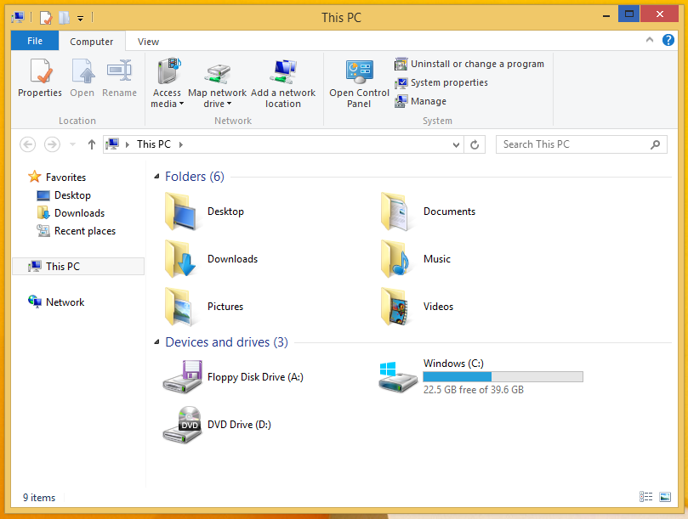 | Click Computer > Add a network location.
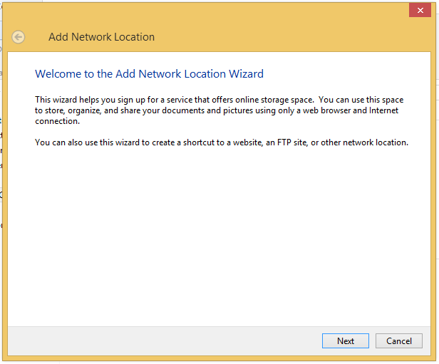 | Press Next.
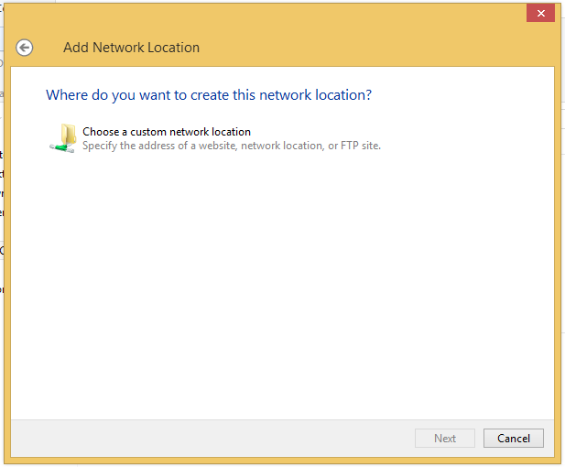 | Select Choose a custom network location and then click on Next.
<putpictureinhere> | In the Internet or network address box type <yourdnsnamehere>and then click on Next
<putpictureinhere> | After a short pause you will be prompted for a username and password.  Enter the same username and password that you use to login to computers.  Then click on OK.
<putpictureinhere> | Click on Next.
<putpictureinhere> | Click on Finish.
<putpictureinhere>
You can then browse your personal documents as well as access any of the shared drives you have permission to.

