Using Cloud
<yournamehere>
02/01/2014

Overview
This guide shows how to connect to Cloud on a Windows XP PC.

Further assistance
If after following this guide further assistance is required contact ICT Services on <yourictservicesemailhere>.

Prerequisites
You must have an active internet connection and a valid user account to be able to complete these steps.

Guide
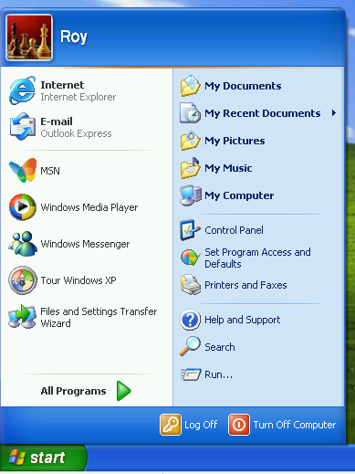 | Go to Start > My Computer.
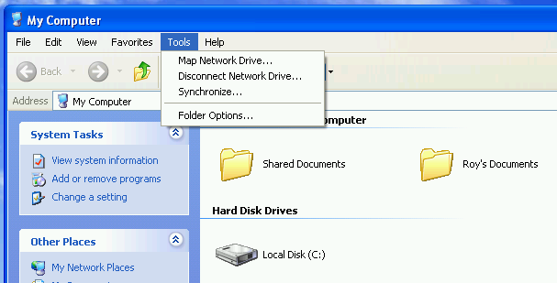 | Go to Tools > Map Network Drive…
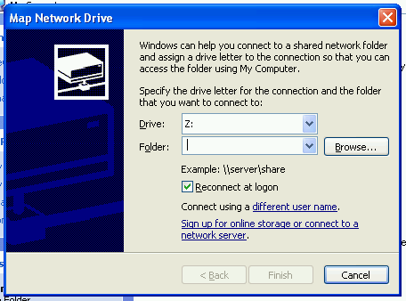 | Click Sign up for online storage or connect to a network server.
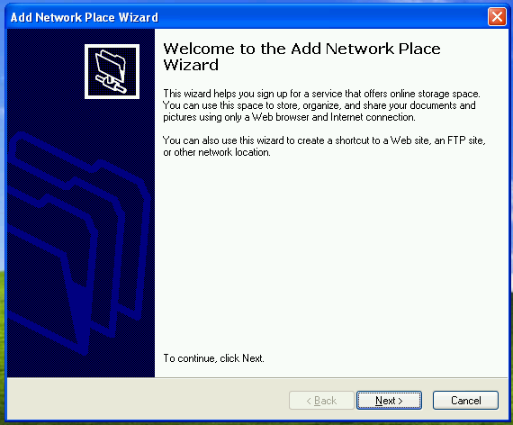 | Click Next.
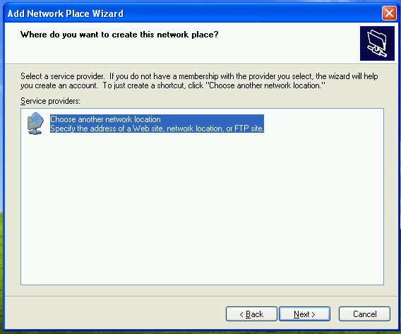 | Select Choose another network location and then click on Next.
<putpictureinhere> | In the Internet or network address box type <yourdnsnamehere> and then click on Next
<putpictureinhere> | After a short pause you will be prompted for a username and password.  Enter the same username and password that you use to login to computers.  Then click on OK.
<putpictureinhere> | Click on Next.
<putpictureinhere> | Click on Finish.
<putpictureinhere>
You can then browse your personal as well as access any of the shared drives you have permission to.

