Using Cloud
<yournamehere>
02/01/2014

Overview
This guide shows how to connect to Cloud on Windows Phones.

Further assistance
If after following this guide further assistance is required contact ICT Services on <yourictservicesemailhere>.

Prerequisites
You must have an active internet connection, a Microsoft store account and a valid user account to be able to complete these steps.

Guide
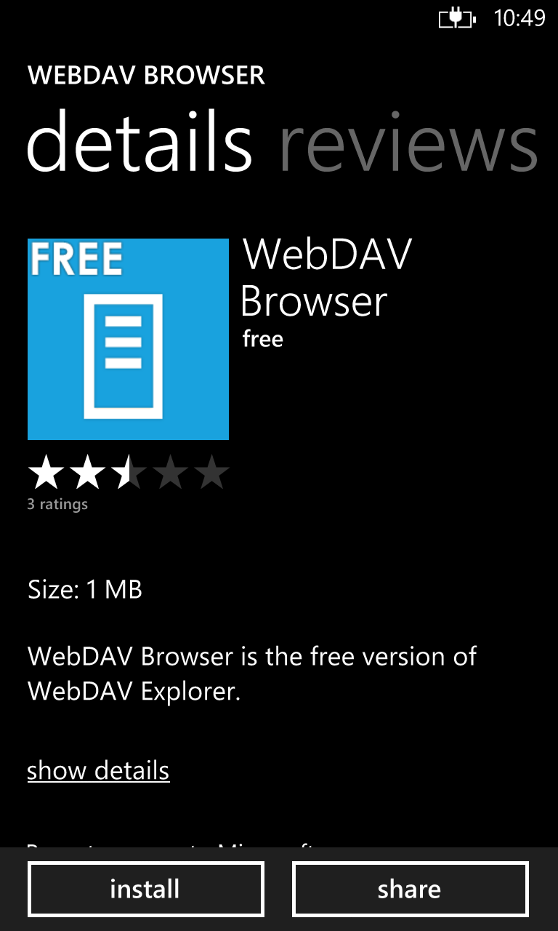 | Search for WebDAV Browser in the store, once found tap install to add it to your phone.
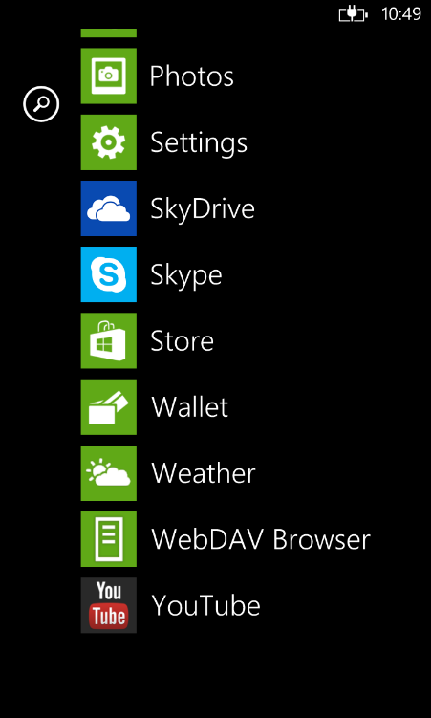 | Launch the WebDAV from the apps list.
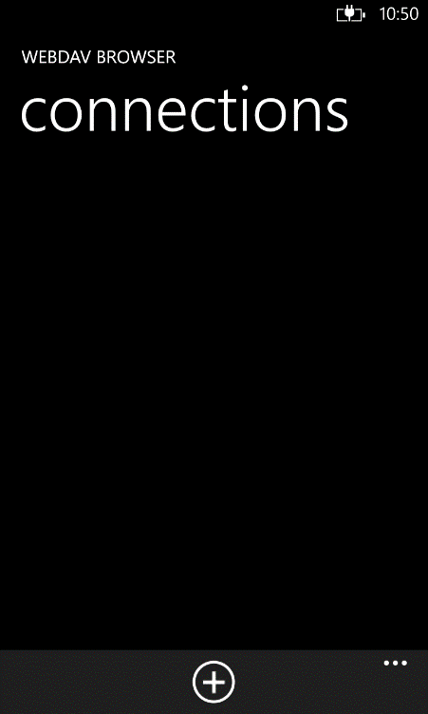 | Tap the + button to add a new connection.
<putpictureinhere> | Enter the following details  Connection name: Cloud  Server address: <yourdnsnamehere>  Login method: Normal
<putpictureinhere> | Scroll down and enter the same username and password that you use to login to computers in the boxes provided.  Then tap the save button.
<putpictureinhere> | Tap the Cloud connection to login.
<putpictureinhere> | You can then browse your personal documents as well as access any of the shared drives you have permission to.

