Using Cloud
<yournamehere>
08/01/2014

Overview
This guide shows how to connect to Cloud on an Apple iOS device (iPhone/iPod Touch/iPad).

Further assistance
If after following this guide further assistance is required contact ICT Services on <yourictservicesemailhere>.

Prerequisites
You must have an active internet connection, an iTunes store account and a valid user account to be able to complete these steps.

Guide
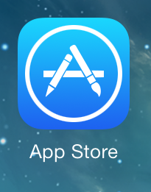 | From the home screen select the App Store.
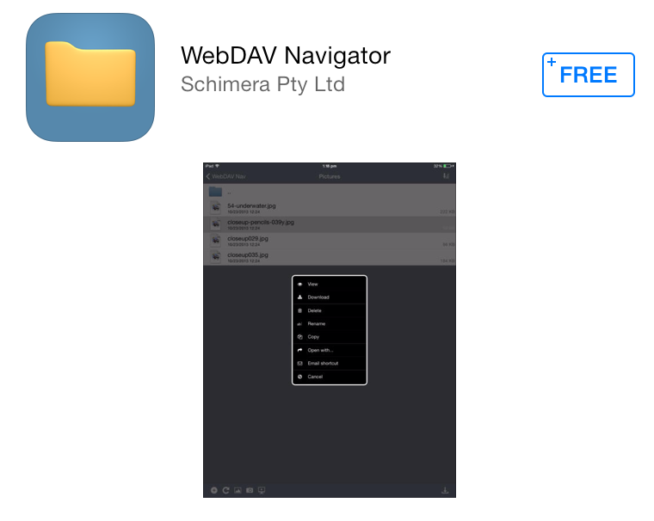 | Search for and download the free WebDav Navigator app.
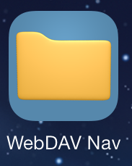 | Once the download has completed launch the WebDav Nav app.
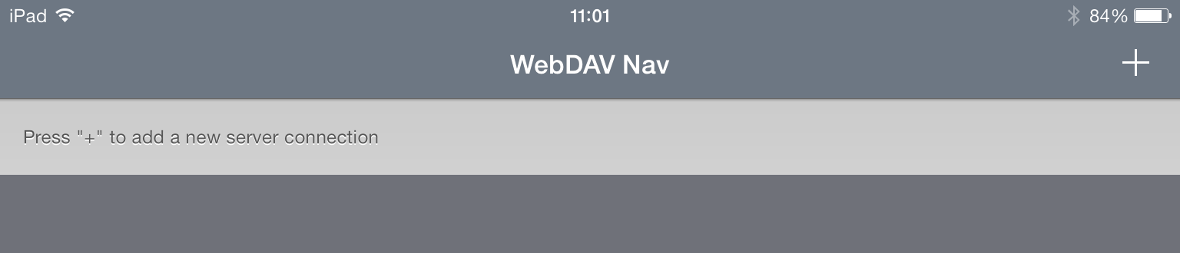
Tap the + icon to add a new connection.
<putpictureinhere>
In the Name box enter Cloud
In Server URL type <yourdnsnamehere>
In the Username box type the same username that you use to login to computers
In the Password box type the same password that you use to login to computers
When done press the Save button
<putpictureinhere>
To access your documents and shared drive(s) tap Cloud
<putpictureinhere>
You can then browse your personal documents as well as access any of the shared drives you have permission to.

