Using Cloud
<yournamehere>
08/01/2014

Overview
This guide shows how to connect to Cloud on an Apple Mac (OSX).

Further assistance
If after following this guide further assistance is required contact ICT Services on <yourictservicesemailhere>.

Prerequisites
You must have an active internet connection and a valid user account to be able to complete these steps.

Guide
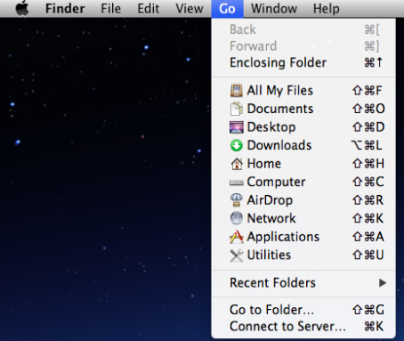 | Go to Go > Connect to Server…
<putpictureinhere> | Type <yourdnsnamehere>then click the + button.  Next click Connect.
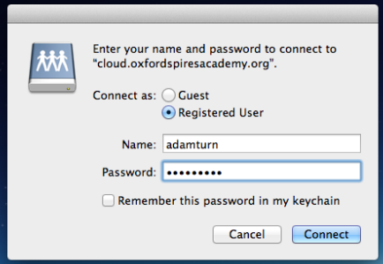 | After a short pause select Registered User and enter the same username and password you use to login to computers in the boxes provided.  Press Connect.
<putpictureinhere>
You can then browse your personal documents as well as access any of the shared drives you have permission to.
Any folders/drives that you do not have access to will be blacked out.

